**Title: The Intricate Art of Decoding Secrets**

**Author: John Doe**

Table of Contents

1. Introduction 3

2. The Cryptic World 3

3. The Code of Leonardo da Vinci 3

3.1 The Vitruvian Man 3

3.2 The Last Supper 3

3.3 Mona Lisa 4

4. Historical Perspectives 4

4.1 Renaissance Art 4

4.2 Priory of Sion 4

4.3 Fibonacci Sequence 4

4.4 Secret Societies 4

4.5 Cryptography 4

5. The Holy Grail 4

6. Symbology Insights 5

6.1 The Sacred Feminine 5

6.2 The Rose 5

6.3 Symbols in Art 5

6.4 Secret Messages 5

6.5 The Keystone 6

7. Parisian Adventure 6

7.1 The Louvre Museum 6

7.2 Saint-Sulpice Church 6

7.3 Rosslyn Chapel 6

7.4 The Templar Revelation 6

7.5 The Final Revelation 6

8. Analysis of Character Development 6

9. Critical Reception and Controversies 7

10. Concluding Thoughts 7

**List of Tables**

Table 1 - First Table 2

Table 2 - Second Table 4

Table 3 - Third Table 5

Table 4 - Fourth Table 6

Table 5 - Fifth Table 7

**List of Figures**

Figure 1 - Depiction of cryptic artifact 3

Figure 2 - Artistic representation of the Holy Grail 4

Figure 3 - Character evolution graph 6

Figure 4 - Chart depicting the critical reception 7

Figure 5 - Symbolic image representing the conclusion 7

# 1. Introduction

Lorem ipsum dolor sit amet, consectetur adipiscing elit. Integer nec odio. Praesent libero.

Table 1 - First Table

|  |  |  |  |  |
| --- | --- | --- | --- | --- |
| # | Procedure | | Results | |
|  | Item Description | ID | Expected | Actual |
| 1 | Item 1 | A1B2 |  |  |
| 2 | Item 2 | X3Y7 |  |  |
| 3 | Item 3 | R2D2 |  |  |
| 4 | Item 4 | Z9X0 |  |  |

# 2. The Cryptic World

Aenean lacinia bibendum nulla sed consectetur. Nullam id dolor id nibh ultricies vehicula ut id elit.

Figure 1 - Depiction of cryptic artifact

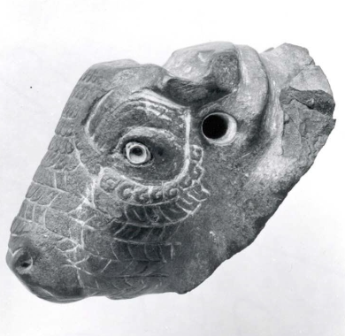

# 3. The Code of Leonardo da Vinci

## 3.1 The Vitruvian Man

Robert Langdon analyzed the Vitruvian Man, a drawing by Leonardo da Vinci. The picture is ink on paper and depicts a man in two superimposed positions with his arms and legs apart inside a square and a circle.

## 3.2 The Last Supper

According to some theorists, the Last Supper is a painting by Leonardo da Vinci with hidden codes. Robert Langdon explores the possibility that hidden messages within the painting relate to secrets about the Holy Grail.

## 3.3 Mona Lisa

Sophie Neveu and Robert Langdon discuss the Mona Lisa and its mysteries. The painting is thought to have codes embedded in it. They discuss the theory that the Mona Lisa is an anagram for "Amon L'Isa," referring to the Egyptian gods of fertility.

# 4. Historical Perspectives

## 4.1 Renaissance Art

Renaissance art is known for its coded messages. Leonardo da Vinci, as a figure of the Renaissance, often employed secret codes and puzzles in his works.

## 4.2 Priory of Sion

The Priory of Sion is a secret society that is central to the plot of The Da Vinci Code. It is claimed to have been involved in preserving secrets about the Holy Grail and the lineage of Jesus Christ.

## 4.3 Fibonacci Sequence

The Fibonacci Sequence is a series of numbers in which each number is the sum of the two preceding ones. In The Da Vinci Code, the sequence serves as a clue to solve one of the mysteries.

Table 2 - Second Table

|  |  |  |  |  |
| --- | --- | --- | --- | --- |
| # | Procedure | | Results | |
|  | Item Description | ID | Expected | Actual |
| 1 | Item 1 | B4C1 |  |  |
| 2 | Item 2 | F2R7 |  |  |
| 3 | Item 3 | L9J6 |  |  |
| 4 | Item 4 | Z9X0 |  |  |

## 4.4 Secret Societies

Secret societies like the Knights Templar and the Priory of Sion are central to The Da Vinci Code's plot. They are believed to have hidden ancient secrets and guarded sacred relics.

## 4.5 Cryptography

Cryptography is used extensively in The Da Vinci Code to hide and decode secret messages. Langdon and Neveu use cryptanalysis to solve the mysteries and unravel the codes.

# 5. The Holy Grail

Lorem ipsum dolor sit amet, consectetur adipiscing elit. Integer nec odio. Praesent libero.

Figure 2 – Artistic representation of the Holy Grail

Figure 2 - Artistic representation of the Holy Grail

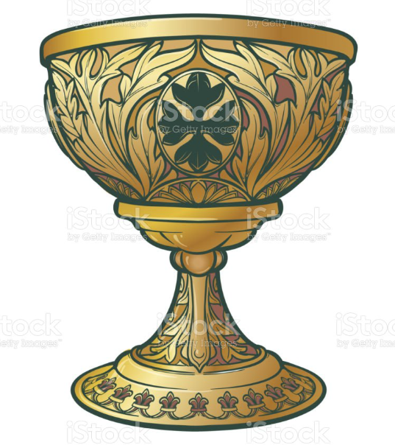

# 6. Symbology Insights

## 6.1 The Sacred Feminine

The Sacred Feminine is a recurring theme in The Da Vinci Code. It symbolizes the importance of women and the feminine side of human nature, which is considered sacred.

## 6.2 The Rose

The Rose is a symbol of secrecy and was used as a symbol by secret societies. In The Da Vinci Code, it represents the Holy Grail and the bloodline of Jesus Christ.

## 6.3 Symbols in Art

Leonardo Da Vinci's art contains a myriad of symbols, according to The Da Vinci Code. These symbols are often religious or related to ancient mysteries.

Table 3 - Third Table

|  |  |  |  |  |
| --- | --- | --- | --- | --- |
| # | Procedure | | Results | |
|  | Item Description | ID | Expected | Actual |
| 1 | Item 1 | R3D4 |  |  |
| 2 | Item 2 | T2Y8 |  |  |
| 3 | Item 3 | L9J6 |  |  |
| 4 | Item 4 | Z9X0 |  |  |

## 6.4 Secret Messages

Secret messages hidden in art and symbols are significant to The Da Vinci Code. Langdon, a symbologist, unravels these messages throughout the story.

## 6.5 The Keystone

The Keystone is an important symbol and object in The Da Vinci Code. It is believed to hold the key to finding the Holy Grail and is sought by various parties.

# 7. Parisian Adventure

## 7.1 The Louvre Museum

In The Da Vinci Code, the Louvre Museum is the site of the curator's murder and the starting point of the clues leading to the Holy Grail.

## 7.2 Saint-Sulpice Church

Saint-Sulpice Church is a significant location in the story. It is where Silas, an antagonist, searches for a keystone by following a line on the floor.

## 7.3 Rosslyn Chapel

Rosslyn Chapel in Scotland is crucial to The Da Vinci Code's climax. The chapel is filled with symbolic art and is believed to be a possible resting place of the Holy Grail.

Table 4 - Fourth Table

|  |  |  |  |  |
| --- | --- | --- | --- | --- |
| # | Procedure | | Results | |
|  | Item Description | ID | Expected | Actual |
| 1 | Item 1 | M9Z3 |  |  |
| 2 | Item 2 | T2Y8 |  |  |
| 3 | Item 3 | L9J6 |  |  |
| 4 | Item 4 | Z9X0 |  |  |

## 7.4 The Templar Revelation

The Templar Revelation is the hidden truth regarding the Knights Templar's role in protecting the Holy Grail, as portrayed in The Da Vinci Code.

## 7.5 The Final Revelation

The Da Vinci Code's story concludes with a final revelation, which ties together the story's mysteries and gives new meaning to the search for the Holy Grail.

# 8. Analysis of Character Development

Lorem ipsum dolor sit amet, consectetur adipiscing elit. Integer nec odio. Praesent libero.

Figure 3 - Character evolution graph

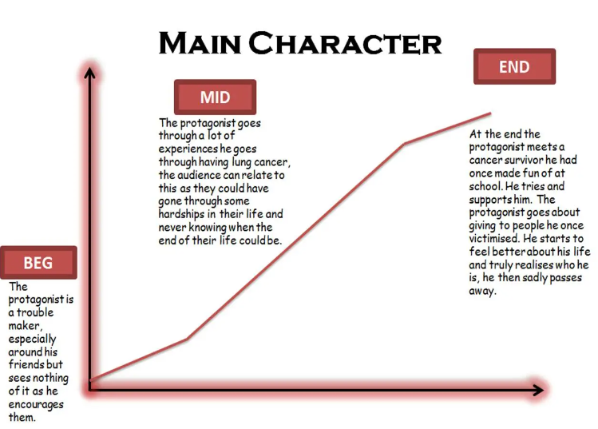

# 9. Critical Reception and Controversies

Lorem ipsum dolor sit amet, consectetur adipiscing elit. Integer nec odio. Praesent libero.

Figure 4 - Chart depicting the critical reception.

Figure 4 - Chart depicting the critical reception

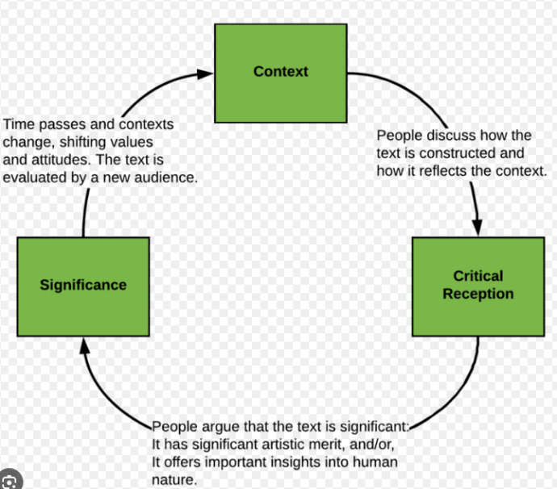

# 10. Concluding Thoughts

Lorem ipsum dolor sit amet, consectetur adipiscing elit. Integer nec odio. Praesent libero.

Figure 5 - Symbolic image representing the conclusion



Table 5 - Fifth Table

|  |  |  |  |  |
| --- | --- | --- | --- | --- |
| # | Procedure | | Results | |
|  | Item Description | ID | Expected | Actual |
| 1 | Item 1 | C5V2 |  |  |
| 2 | Item 2 | T2Y8 |  |  |
| 3 | Item 3 | L9J6 |  |  |
| 4 | Item 4 | Z9X0 |  |  |